**Practical 3**

**Built an IoT system to send ticket before entering the bus**

**Steps to Perform:**

**Step 1:** 1) Take LCD

2) Take Component - MCU Board

3) Take RFID Reader

4) Take DLC Home Gateway

5) Take PC

6) Take Door

7) Take RFID Card

**Step 2:** 1) Now we will connect LCD to MCU Board with IoT custom cable

connect LED (D0) to MCU Board (D0)

2) Then go to the RFID Reader click on Advanced then click i/o config

then go the Analog slots and collect value 2 then close.

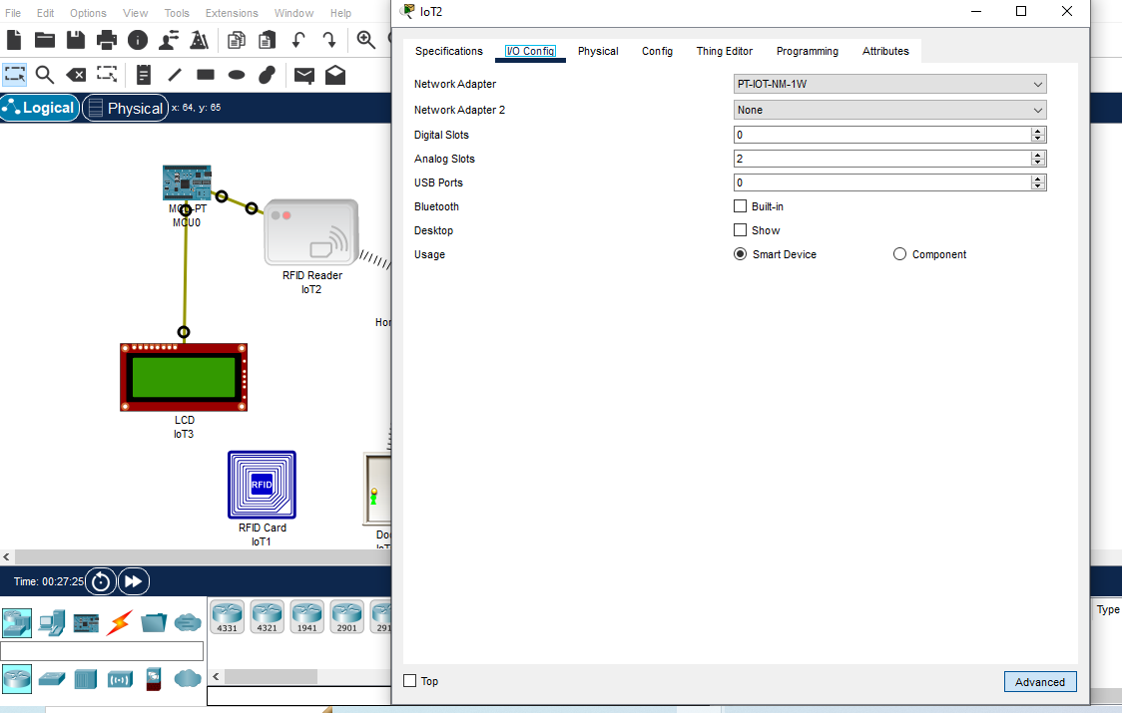

3) Now we will connect RFID Reader to MCU Board with IoT custom cable connect

RFID Reader (A1) to MCU Board (A0)

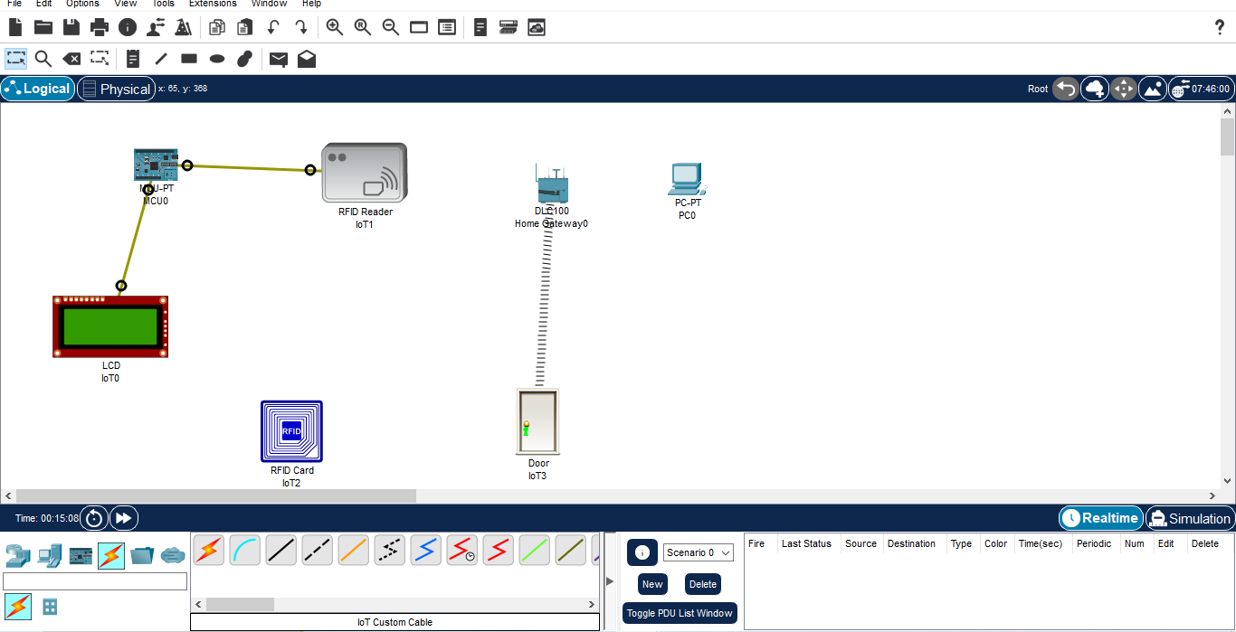

**Step 3:** 1) Click on pc then go to the physical then switch off then select PT-HOST-NM-1W

Then switch on.

2) Then go to the config click on wireless0 then select HomeGateway then close

3) Then go to RFID Reader click on i/0 config then select network Adapter (PT-IOT-NM

1W) then go to config and select Home Gateway

**Step 4:** 1) Now click on MCU Board go to Programming then Select New, Select Template-

Empty-Python then click on Create

2) Click on main.py file then write code

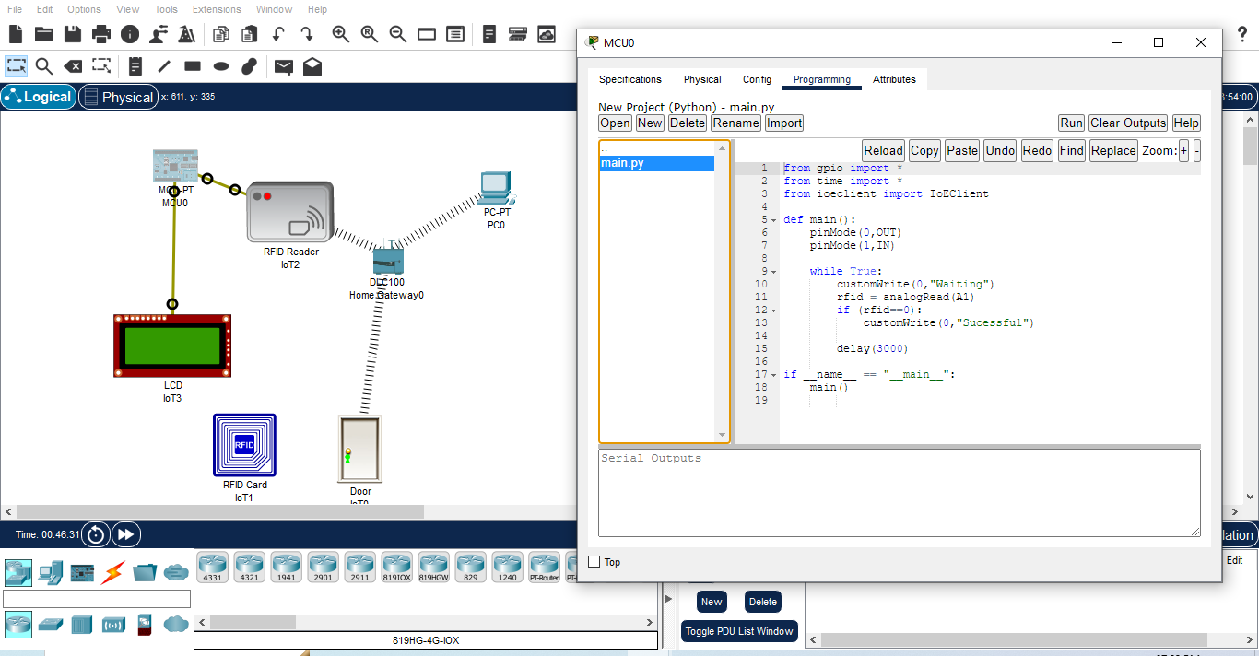

**Code:**

from gpio import *

from time import *

from ioeclient import IoEClient

def main():

pinMode(0,OUT)

pinMode(1,IN)

while True:

customWrite(0,"Waiting")

rfid = analogRead(A1)

if (rfid==0):

customWrite(0,"Sucessful")

delay(3000)

if __name__ == "__main__":

main()

**Step 5:** 1) Click on Run

2) Drag RFID Card and Drop in front of RFID Reader

